**Sunday** (Sara Lee)

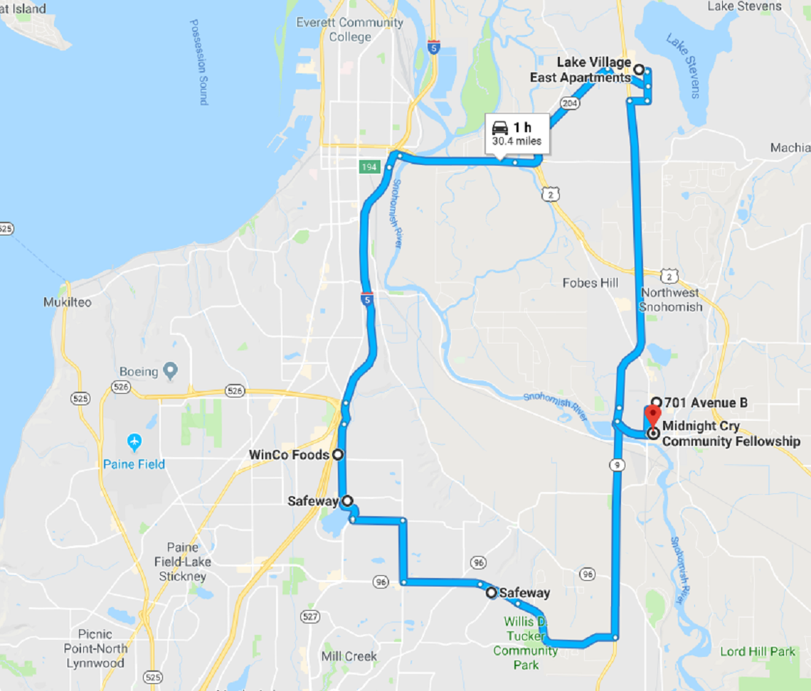

Notes: